Name: Rishika Soni
RollNo: 48
Sec/Batch: A3

Practical No.6

AIM: Demonstrate and Implement Sub queries
Employee Table:
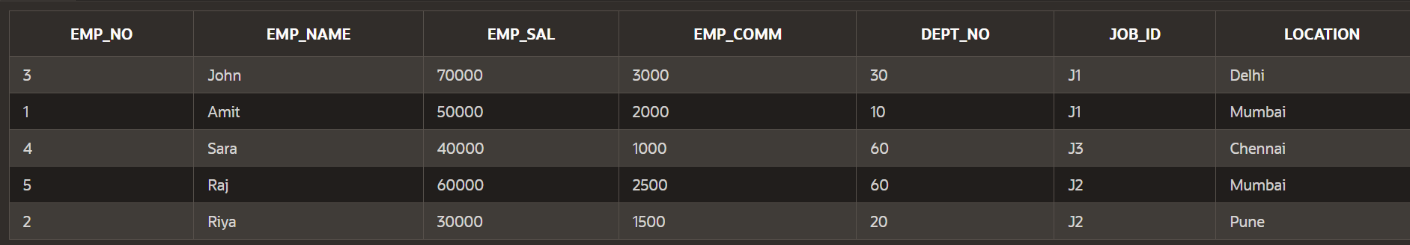
Job Table:

Department Table:

Employee_manager:


1. Create a report that displays the employee number, name, and salary of all
employees who earn more than the average salary. Sort the results in order of
ascending salary.
SELECT emp_no, emp_name, emp_sal FROM Employees
WHERE emp_sal > (SELECT AVG(emp_sal) FROM Employees)
ORDER BY emp_sal ASC;
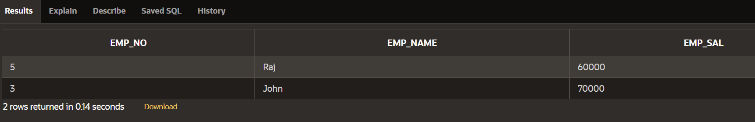

2. The HR department needs a report that displays the name, department
number, and job ID of all employees whose department location ID is 1700.
SELECT emp_name, dept_no, job_id FROM Employees
WHERE dept_no IN (
SELECT dept_no FROM department WHERE location_id = 1700
);
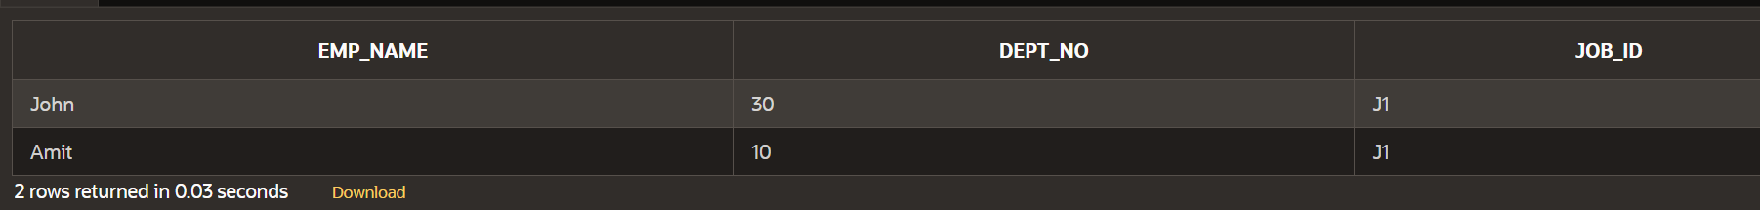
3. Create a report for HR that displays the department number, name, and job
ID for every employee in the Executive department.
SELECT dept_no, emp_name, job_id FROM Employees
WHERE dept_no IN (
SELECT dept_no FROM department WHERE dept_name = 'Executive'
);

4. Create a report that displays a list of all employees whose salary is more than
the salary of any employee from department 60.
SELECT emp_no, emp_name, emp_sal FROM Employees
WHERE emp_sal > ANY (
SELECT emp_sal FROM Employees WHERE dept_no = 60
);
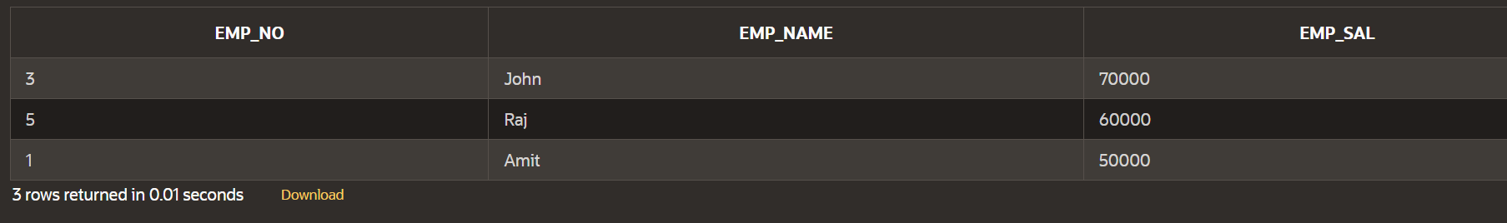

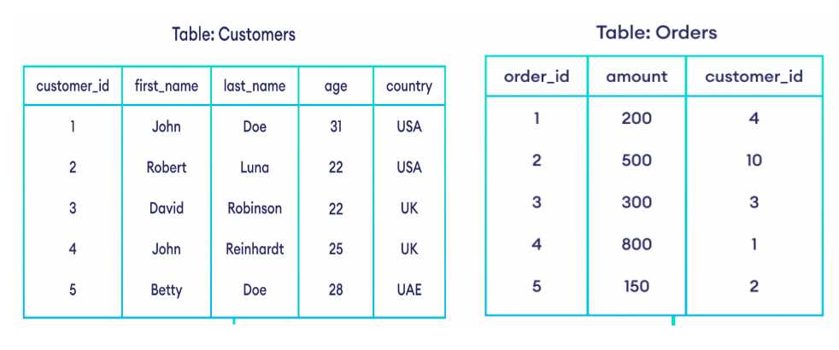
Customer :
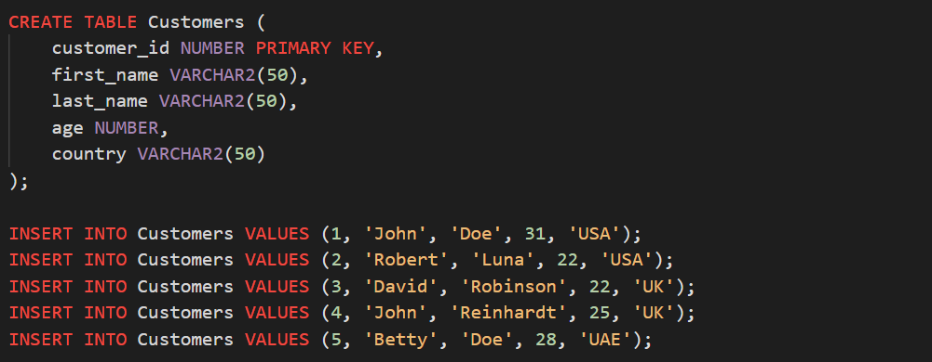
Orders:
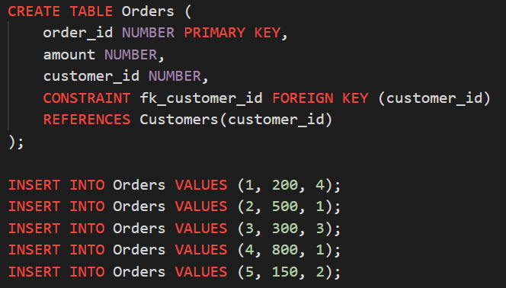

1. Find the details of customers who have placed an order.
SELECT *
FROM Customers
WHERE customer_id IN (
SELECT customer_id FROM Orders
);
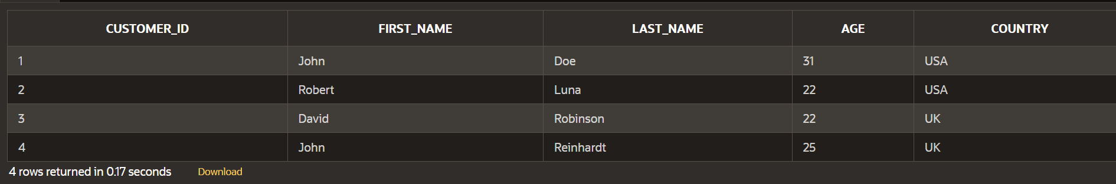

2. Find all customers who do not have order more than $500
SELECT * FROM Customers c
WHERE NOT EXISTS (
SELECT 1
FROM Orders o
WHERE o.customer_id = c.customer_id
AND o.amount > 500
);
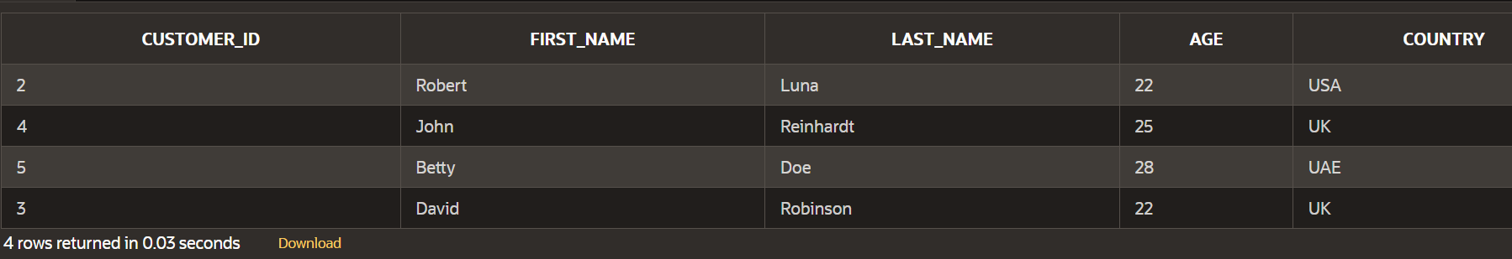

3. Find the customers who have placed highest order.
SELECT * FROM Customers
WHERE customer_id IN (
SELECT customer_id
FROM Orders
WHERE amount = (SELECT MAX(amount) FROM Orders)
);
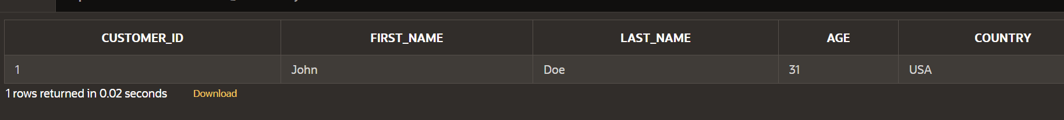

4. Find all customers whose age is greater than the average age of all customers.
SELECT *
FROM Customers
WHERE age > (SELECT AVG(age) FROM Customers);


5. Find the name of customers whose age is equal to age of John.

SELECT first_name, last_name FROM Customers
WHERE age IN (
SELECT age FROM Customers WHERE first_name = 'John'
)
AND first_name <> 'John';
